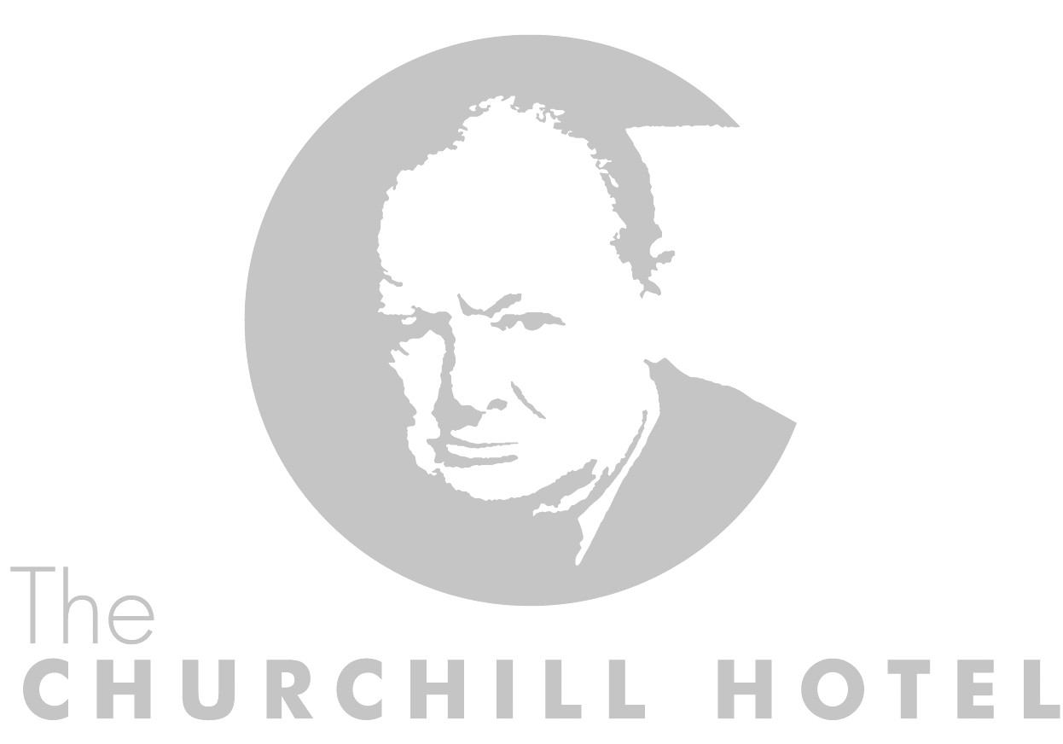

Thank you for your interest in The Churchill Hotel for your forthcoming wedding celebration. I am delighted to enclose our Wedding Menus which I trust will be of interest to you.

The Churchill is a privately owned and run hotel & owes much of its appeal to the unique atmosphere of a Georgian mansion, located within walking distance of York city centre. The Churchill stands in its own beautifully cultivated gardens and boasts ample secure parking for all its guests.

Lovingly restored in the spring of 1986 the new owners, Messrs Dewsnap & Wood, purchased the property and undertook extensive alterations and repairs to the building, restoring it to its former glory. Initially The Churchill opened as a fourteen bedroom hotel then in 2006 a new chapter in the house's history began with the complete refurbishment of the original building and a sympathetic extension being added resulting in a 32 bedroom luxury hotel, fine dining restaurant and elegant function rooms.

The hotel has gained a wonderful reputation both locally and with guests further afield for its fine food and warm hospitality.

All wedding receptions and private dinners are unique, so listening and understanding all your needs is very important to us, therefore the choices offered are only suggestions.

Daytime receptions can be held in the Westminster Room for up to 100 guests. The hotel can also offer alternative function rooms to cater for more intimate celebrations of 20-40 guests. Evening entertainment, finger buffets and a private bar can be arranged and we can cater for up to 120 guests at night-time.

Please feel free to contact me and discuss any queries you may have regarding the Hotel and its facilities or why not pop in and see me at a mutually convenient time to discuss your requirements further over a coffee.

Yours faithfully

John Wallace
General Manager

Your Special Day

Let us take you through your Special Day...

Your guests may take arrival drinks while the Bride and Groom have photographs taken.

Having relaxed with your friends and family the next step is to receive them.

May we suggest the following order:

Bride’s Mother
Bride’s Father
Bridegroom’s Mother
Bridegroom’s Father

Bride
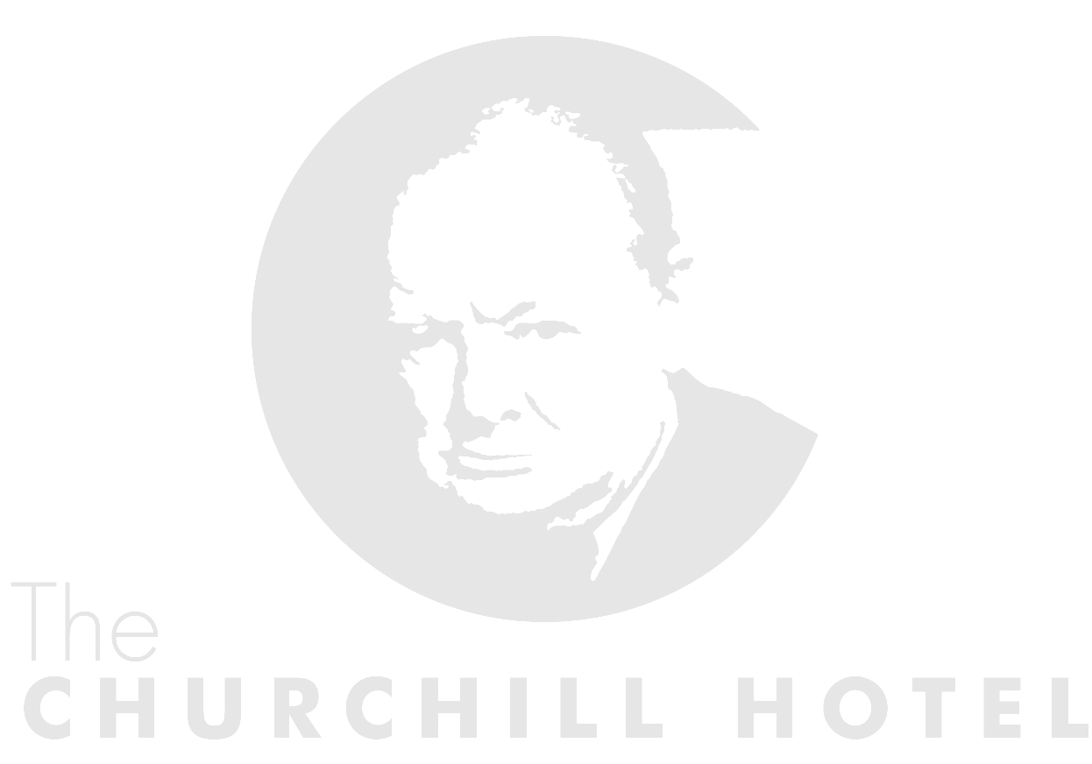
Bridegroom
Bridesmaids
Best Man

The Top Table
Best Man
Chief Bridesmaid
Bridegroom’s Father
Bride’s Mother
Bridegroom
Bride
Bride’s Father
Bridegroom’s Mother
Bridesmaid (s)

Toasts and Speeches

After dessert the Master of Ceremonies will call on you to cut the cake.

Once cut, a tier will be taken away to be served with coffee and the toast.

The speeches commence after the coffee and cake has been served and ‘bubbly’ poured.

Your Master of Ceremonies invites the Bride’s Father or close relative to toast the Bride and Bridegroom.

The Bridegroom will respond, thanking the Bride’s parents and the wedding guests for attending and their presents received and finally toast the Bridesmaids

The Best Man responds on behalf of the Bridesmaids, reads out the cards and telegrams and toasts the parents of the Bride and Bridegroom

Daytime Receptions Include:

Reception Room Hire

Excellent Photographic Opportunity within the Hotel Grounds

Master of Ceremonies Facility

Appropriate Background Music

Wedding Cake Stand & Knife

Private Bar Facilities

Young guests are charged half price up to the age of 8 years

High Chairs available

Free car parking in available, marked spaces in the hotel grounds.

Also available at an extra cost:

Married on premises £300.00 for Ceremony Room Hire

Pianist £110.00 for a ceremony or for during arrival drinks.

Canapés on arrival £6 per person

Fresh Flower displays and table pieces can be arranged at the prices charged by our florists.

Function Room with DJ for an evening reception to follow your wedding breakfast £350*

Function Room hire for an evening reception to follow your wedding breakfast £250*

*ordinarily we do insist upon a buffet being ordered for your evening reception although this can be discussed during the planning of your wedding

Prices may vary in 2016

Wedding Breakfast Menus

To create the menu for your wedding breakfast; please select one starter, one main course and one dessert from the selections below.

The main courses are listed first with a price against each selection. Choose a main course initially, this dictates the meal cost, then proceed to pick the starter and dessert to accompany it.

The price listed with the main courses is the total cost of the entire three course meal, with coffee and mints to follow. Should you wish to choose from a more expensive selection of starters and desserts than the choice of main course would ordinarily allow then you can do so with the relevant supplements being added.

Main courses will be accompanied by appropriate seasonal vegetables and potatoes.

You may also wish to select a vegetarian option to offer your guests and other dietary requirements can then be catered for on an individual basis.

Main Courses

Selection 1

£34.00 per person

Braised beef blade, Bourginonne sauce, horseradish pomme puree

Roast pork loin, bramley apple sauce, crackling and sausage meat stuffing

Grilled salmon fillet, watercress sauce

Wild mushroom risotto, Parmesan shavings, white truffle oil (V)

Chicken breast, creamed cabbage and bacon

Mozzarella stuffed beef tomato, pipperade and basil pesto (V)

Selection 2

£36.50 per person

Slow roast lamb shoulder, fondant potato and creamed goats cheese

Confit belly pork, choucroute and glazed carrots

Confit duck leg, caramalised onion pomme puree, redcurrant sauce

Chicken cordon bleu, roast chicken wing sauce, pomme mouselline

Wild mushroom, goats cheese and spinach pithivier (V)

Pan fried trout fillet, crushed new potatoes, tomato and cockle vinaigrette

Selection 3

£39.00 per person

Roast leg of Yorkshire lamb, green beans and pancetta

Pork fillet wrapped in proscuitto crudo ham, apples, onions and garlic

Roast sirloin of beef, Yorkshire pudding and onion gravy

Cod chunk, confit tomato, mushroom duxcelle, spinach and chive butter sauce

Sea Bass fillets, braised pak choi, brown shrimp butter.

Selection 4

£47.50 per person

Yorkshire beef fillet “Wellington” - Wild mushrooms, spinach, puff pastry and thyme jus

Grilled Half Lobster served with Thermidor sauce or simple garlic butter*

Pan fried Turbot fillet, Wild mushrooms, Salsify and Spinach, red wine sauce*

Goosenargh corn fed duck breast, potato rosti, quince, chicory and girolle mushrooms

Venison loin, beetroot, apple and sorrel*

*These dishes, more than most, are subject to significant seasonal price variations. We will endeavour
to offer these choices for £45 per person but the Head Chef will confirm, at the time of booking, the likely
price for this menu.

Starters:

Selection 1

Available with any main course selection

Choice of homemade soups:-
Tomato and basil
Leek and potato
Watercress
Carrot and coriander
Wild mushroom

Smoked salmon with classic accompanients

Truffled chicken liver parfait, grape chutney and brioche

Ham hock and egg terrine, pineapple chutney

Wild mushroom risotto cakes, rocket and parmesan salad (V)

Garlic mushrooms on toasted brioche, chive crème fraiche (V)

Prosscuito crudo ham and seasonal melon

Warm goats cheese and red onion marmalade tart (V)

Spinach and potato frittata, gruyere cheese shavings and dressed leaves (V)

Selection 2

Available with those main courses priced at £36.50 and above
or at a £2 per person supplement on the other menus.

Choice of homemade soups:-
Split pea and Yorkshire ham, parsley oil
Mutton broth
Smoked Haddock Chowder, puff pastry lid
Oxtail consomme, royale garnish

Warm black pudding and pancetta salad, soft poached egg, mustard seed dressing

Confit duck leg ballotine, apricot chutney, crisp onion bread

The Churchill prawn cocktail, crispy gem lettuce, tomato and cucumber

Twice baked Yorkshire blue cheese souffle, baby mixed leaves, walnut dressing (V)

Selection 2 continued

Salmon and cod fishcakes, watercress and tomato dressing

Cornfed chicken and artichoke terrine, truffled quail egg

Smoked duck, celeriac remoulade and pea shoots

Selection 3

Available with those main courses priced at £47.50
or for a £5 per person supplement on the other menus.

Lobster cocktail, baby gem, confit tomato and marie rose sauce

Organic salmon ballotine, watercress and chive fromage frais

Whitby crab, chive mayonaise and bloody mary dressing

Beef carpaccio, bocconcini mozzarella and micro roquette

Seared foie gras, port wine syrup, gingerbread and mango*

Cocquiles st Jacques

*We can only offer this choice for up to a maximum of 40 guests

Desserts

Selection 1

Available with any main course selection

Traditional crème brulee, shortbread biscuit

White chocolate mousse, dark chocolate ice cream

Lemon and lime cheesecake, raspberry compote

Sticky toffee pudding, butterscotch sauce and vanilla ice cream

Profiteroles, baileys cream and dark chocolate sauce
Apple crumble, warm vanilla anglaise

Selection of homemade ice creams or sorbets

Lemon Posset, berry compote and cat's tongue biscuits

Selection 2

Available with those main courses priced at £36.50 and above
or for a £2 per person supplement on the other menus.

Dark chocolate tart, blood orange sorbet, frosted pistachios

Apple tart tatin, wensleydale cheese ice cream

Dark chocolate marquise, malt barley ice cream, salted butter caramel

Glazed lemon and orange tart, berry coulis

Caramalised rice pudding with gingerbread cake

Champagne jelly, poached fruits and clotted cream

Yorkshire cheeseboard, celery, apple chutney, grapes and biscuits

Raspberry pavlova, clotted cream ice cream and lemon balm syrup

Selection 3

Available with those main courses priced at £47.50
or for a £5 per person supplement on the other menus.

Raspberry mille feuille, lemon posset and praline

Strawberry and white chocolate meringue, clotted cream

Poached cherries, kirsch soaked savarin and cherry sorbet

Tasting of Yorkshire forced rhubarb*
*Yorkshire forced rhubarb is only typically available from December until April. This dish can be offered at other times but the likelihood is that it would then need to be created with imported forced rhubarb

Evening Reception Buffets

Finger Buffet 1
£14per person

Select two toppings for sandwiches, two flavours of pizza plus one skewer and one hot snack

Finger Buffet 2
£16 per person

Select three toppings for sandwiches and two types of pizza, skewer and hot snacks.

Fork Buffet 1
£14 per person

Select two dishes from the hot food selection and two salads

Fork Buffet 2
£17 per person

Select two dishes from the hot food selection, three salads and a dessert.

Finger Food

Selection of open sandwiches

Yorkshire roast ham - Smoked salmon and cream cheese - Mature cheddar and pickle -

Prawn with marie rose - Lamb Tikka - Egg Mayonnaise - Roast chicken

Rare roast beef and horseradish - Tuna Mayonaise

Choice of homemade pizza

Pepperoni - Tomato and mozzarella – Chicken and mushroom – Yorkshire Ham

Tuna and prawn - Mushroom

Choice of hot skewers

Chicken Satay - Lamb Koftas - Prawn and lemon grass - Beef and pepper

Roast vegetable - Chicken and chorizo - Salmon and cod

Finger Food continued

Choice of hot snacks

Indian Selection - Dim Sum – Spicy Potato wedges - Vegetable Spring rolls - Fishcakes

Fork Buffet Selection

Hot food

Green Thai chicken curry - Beef and Guinness Pie, puff pastry lid - Coq au Vin

Lamb Navarin - Roast vegetable penne pasta - Choucroute Garni - Confit duck leg casseulet
Chargrilled aubergine, tomato and goats cheese - Fish and prawn pie, cheddar mash

(All above served with a suitable accompanients)

Choice of salad

Mixed leaf - Rocket and Parmesan - Waldorf - Traditional Ceasar - New potato and chive

Tomato and mozzaralla - Blue cheese and walnut - Panzanella - Watercress - Coleslaw

Desserts

Mini dessert selection - Fresh fruit platter - Local cheese selection, biscuits, chutney and celery

Chocolate and hazelnut or fresh fruit pavlova to share - Chocolate and marshmallow fondue

Midnight Munchies and lighter snacks
£7.50 per person

Either select any single dish from the Hot Food section above or alternatively we can also serve your choice of the following to your guests as a lighter alternative to a buffet:

Bacon and sausage sandwiches – A varied selection of pizzas -

Hogroast sandwiches, roast pork loin with stuffing, crackling and apple sauce in a floured bap

Drinks Packages

Menu 1
£15.50
A Glass of Sherry on Arrival
Two Glasses of our House Wine
A Glass of Sparkling Wine for the Toast

Menu 2
£16.75
Bucks Fizz on Arrival
Two Glasses of our House Wine
A Glass of Champagne for the Toast

Menu 3
£19.75
A Glass of Champagne on Arrival
Two Glasses of our House Wine Wine
A Glass of Champagne for the Toast

Alternative Arrival Drinks:
Supplement per person
Kir £1.35
Bucks Fizz £1.70
Mulled Wine £1.40
Summer Punch £1.35
175ml Glass of Wine £1.70
Glass of Fruit Pimms £1.95

Alternatives to our House Wine:

Wildekrans Chenin Blanc (South Africa) & Urban Malbec (Argentina) £3.25
Macon Lugny Louis Latour & Regnie de Beaujeu (France) £4.50
Mud House Pinot Gris (New Zealand) & Raka Pinotage (South Africa) £5.00
Pouilly Fuisse Albert Bichot & Chateau Pipeau Grand Cru St Emilion (France) £9.50

Champagne Toast upgrades:

Pol Roger NV £3.50
Pol Roger Vintage Rose £6.00
Pol Roger ‘Sir Winston Churchill’ Vintage £16.00

We are always open to discussion regarding your individual requirements and to make further suggestions from our extensive wine list.

Terms & Conditions

Please ensure that you carefully read through the following terms and conditions which will apply to your function here at The Churchill Hotel:

Confirmation

Should you wish to book a date for your function we will require a non-refundable, non-transferable booking deposit of £500 together with a signed copy of these terms and conditions.

Charges

The prices charged for your wedding will be those provided at the time of your confirmation.

Payment
In addition to the confirmation deposit of £500 a further non-refundable payment of £500 will be required 6 months prior to the event.

Final payment is required 7 days prior to the event with the confirmation of final numbers being provided 30 days prior to the event.

Should deposits and pre-payments not be received and funds cleared by the date of the function we may treat the booking as being cancelled.

Please note that a 3% handling charge will be levied on all monies paid by credit card.

Cancellations
In the unfortunate circumstances of you having to cancel or postpone your confirmed booking at any time prior to the event, The Churchill Hotel will make every effort to re-sell the facilities on your behalf.

Any cancellation, postponement or partial cancellation should initially be verbally advised to a The Churchill Hotel staff member. All cancellations must be confirmed in writing and facilities cannot be released for re-sale until this is received. Written acknowledgement will then be sent by The Churchill Hotel.

Definitive cancellation charges due can only be confirmed after the intended date of the event, when we may reduce the charge by any alternative business we have been able to secure on your behalf less the cost of having to secure it.

In the event of The Churchill Hotel being unsuccessful in re-selling the cancelled or amended booking at the same value as your event, cancellation charges will be levied as follows:

Period of notice for Cancellation/partial cancellation/postponement:
Over 12 months – Loss of non-refundable deposit
6 to 12 months - 25% of quoted price.
1 to 6 months - 50% of quoted price.
Less than 1 month – 100% of quoted price.

Should you wish to make any significant changes to your event or the expected number of guests, The Churchill Hotel reserves the right to amend the rates and the facilities offered.

Insurance
We suggest that you take out wedding insurance to protect you from cancellation charges and would be pleased to provide you with some insurance company contacts.

Menus:

We require your choice of menu at least one month prior to the date of your function. All guests must select the same menu, but we can, with prior notice, cater separately for vegetarians or any special dietary requirements.

Rooms
Where individuals or groups have booked accommodation, standard cancellation Terms and Conditions apply. All rooms must be booked through our Reservations Team.

Our rooms are of a very high standard and it takes time to keep them this way, therefore rooms are not available to check into until 2p.m. Should they be required earlier we will endeavour to meet your requests but should this be an absolute necessity then we will require at least 14 days written notice and there will be a £30 surcharge per room (the earliest time they will then be ready is 12p.m.).

Etiqette
The Hotel reserves the right to judge acceptable levels of music or behaviour of the client, guest or representative and the client must take all steps necessary for corrective action should this be necessary. In the event of failure to comply with management requests, the Hotel reserves the right to terminate the contract or stop the event without being liable for any refund or compensation.

For those wedding receptions which include an evening reception please note that the function bar will close at midnight for all guests and entertainment must cease at this time. Residents staying in the hotel only may use the Piano Bar until 1am.

Damage

Should any damages occur at The Churchill Hotel property or grounds as a result of a wilful act or default of you, any service contractors you have arranged or your guests you will be liable for the cleaning, repair or replacement as appropriate of damaged items including compensation for loss of business while such damage is being repaired.

Additional Expenses
The client agrees to pay the Hotel for any food, beverage or other services not provided for in the planning of your wedding but made available upon request of the Client.
General

Please note that The Churchill Hotel is strictly non-smoking throughout. Smoking areas are provided.

Please refrain from throwing confetti within the hotel as it spoils the hotel’s appearance for other guests. On the front lawn is acceptable, however.

Due to local environmental and planning restraints, firework displays are not allowed.

Any vehicles parked at The Churchill Hotel are done so entirely at the risk of the drivers

The Churchill Hotel shall be under no liability if they are unable to carry out provision of the contract for any reason beyond their control including (without limiting the foregoing) Act of God, legislation, war, fire, flood, drought, failure of power supply, lock out, strike, or other action taken by employees in contemplation of furtherance of a dispute or owing to any inability to procure materials required for the performance of the contract. In these circumstances, every effort will be made to accommodate the booking in another hotel of similar standard.

Please do not hesitate in contacting us should you have any queries with regards to the above terms and conditions.

I have read and accept the terms and conditions as set out above:

Signature ……….………….……………. Name ………….………….………… Date ………………..

